Chapter Meeting Summon

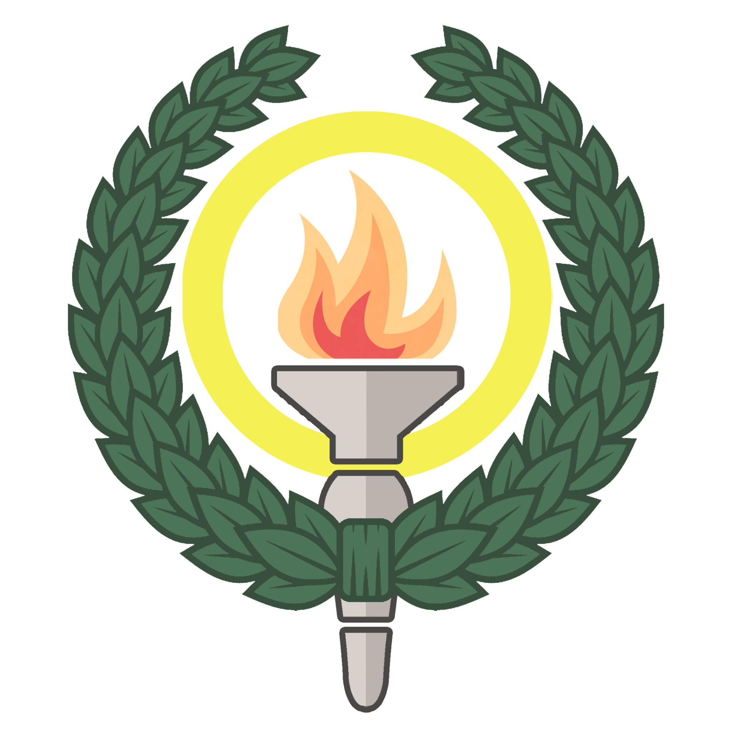

Invited: Chapter members Dr/THS; ABE/CBH/EECS/ITM/SCI PhD councils; Union council representatives Dr/THS; Chapter functionaries Dr/THS; Female Doctoral Committee (WoP) Dr/THS; Auditors Dr/THS;

Attention to (co-opted): Board/THS; Head of Educational Affairs/THS

Place: T-Centralen (Drottning Kristinas väg 29)

Sign up here
Time: 17:30 onwards, 4th of November of 2026

